*Create the table and do follow the questions*

1. We need to create the table bank
2. Insert the values into the table
3. By using the where clause by comparision operator
4. Use between clause for the table
5. *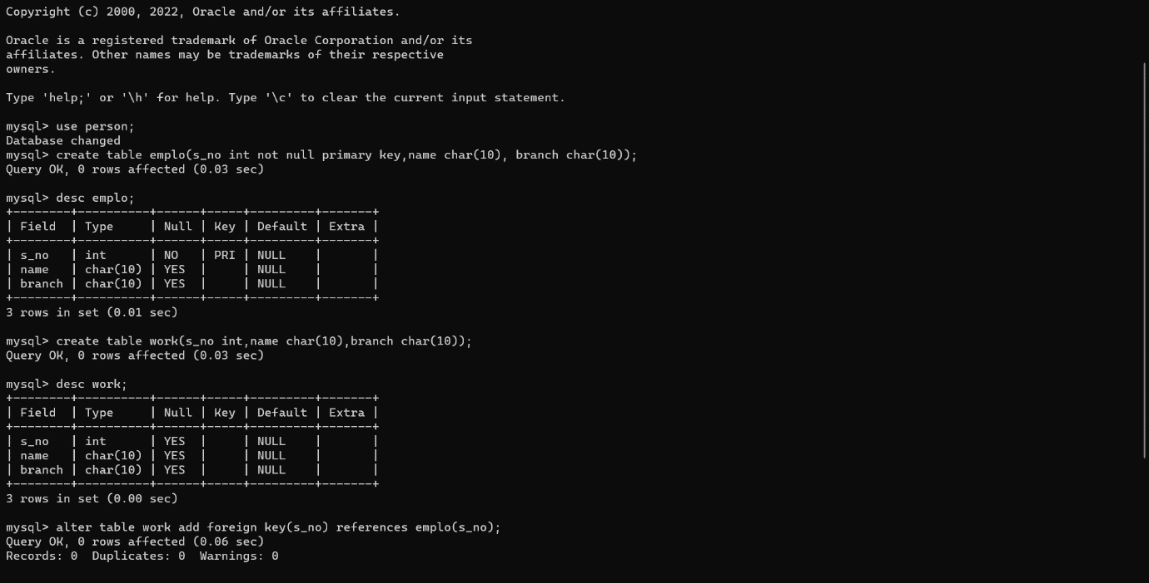*Update the branch in the column column